Assignment 7

Name Muhammad Ali

Sid 9363

Cid 102326

Design A Bus Network Which Consist Of Three Router Attach Two Pc With Router 1 Switch And Five Pc With Router 3 Switch Attach A Web,dns,ftp,telnet,email server With Router 1 Switch Configure Extended Acl On This Network So That All The Authorize User Can Acess Web,dns,ftp,telnet,email server While Unautherize Should Be Restricted

Network Diagram

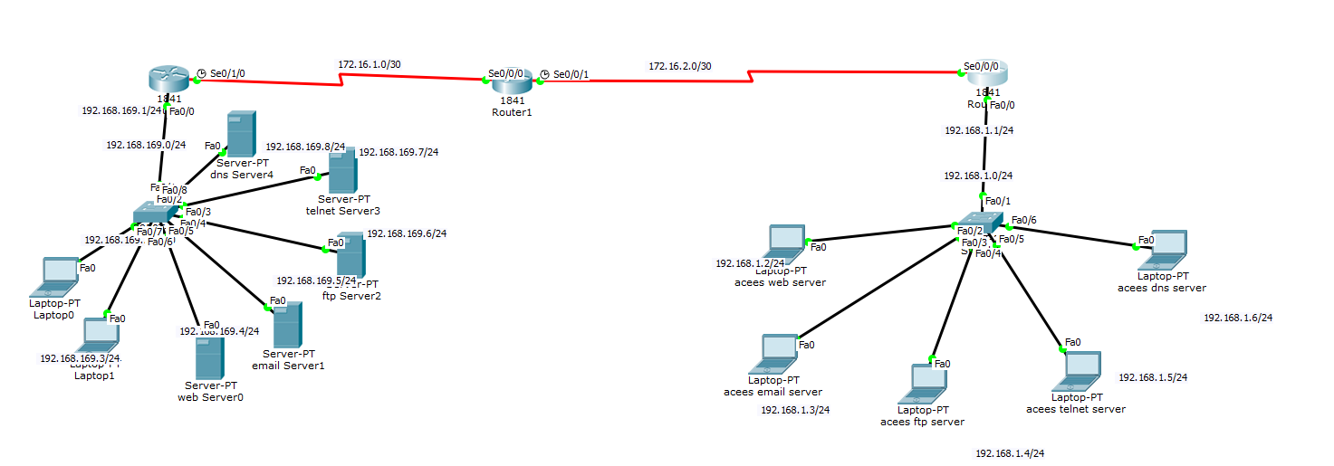

R3 Show Running

ACL Code

